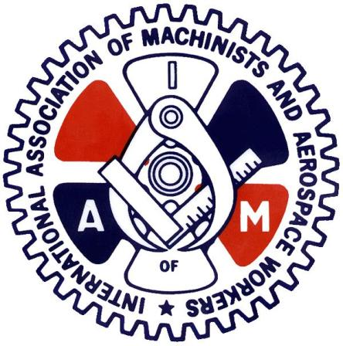

CAE MILITARY AVIATION TRAINING

Dear Brothers and Sister of CAE,
On March 22nd to March 24th, we held a ratification vote to roll over the current Collective Agreement for 1 year. The results of the vote were that the membership voted in favour of rolling over the current collective agreement.
Therefore, all the same language and pay scales outline in the CBA will stay the same.
We hope that the next year will allow enough time for this Covid Pandemic to settle and we can enter into meaning full bargaining next year.
Hope everyone is safe and Healthy during these difficult times we are in!

Stay Safe!
In Solidarity

Kevin Timms
General Chairperson DL140

