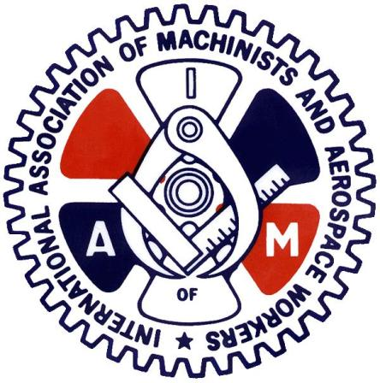
CAE MILITARY AVIATION TRAINING

IAMAW Members for CAE MILITARY AVIATION TRAINING, your DL140 rep reached out to the company last month to give intent to enter bargaining as outlined in your CBA. Shortly after we reached out to the company, to inquire if they had any interest to extend the current CBA by 1 year. Your DL140 rep feels this would be the best course of action given the current state of the economy and the on-going global pandemic. We feel that if we were to start Collective Bargaining now it would most likely be more concessionary than anything else. After a few conversations between the company and us, the company has agreed to extend the current CBA by 1 year.
The membership still has their say in this, so we will set up a ratification vote for you all to vote on. The voting will open on March 22nd at 0800EST closing on March 24th at 1800EST.
This Vote will be to roll over the current CBA for 1 year.
With the current covid restrictions we will be setting up an electronic voting system, so we ask everyone to please give your current up to date personal email to Shauna Sinclair so that we may send out the proper link and access code for the vote. She can be reached at shaunafisher@sasktel.net. Please have your email address updated by March 17th by the latest.

In Solidarity
Kevin Timms
General Chairperson DL140

