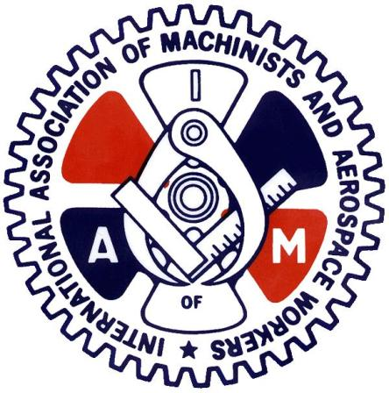
CAE MILITARY AVIATION TRAINING

Clarity on the Roll Over vote!

Today I write to clarify a question that has been raised by a few members.
The question was, if the membership votes in favor of rolling over the current CBA for 1-year, next year when we negotiate a new contract is it retro-active to this year?
And the answer is NO, the vote to roll over the current CBA is ratifying the existing contract for 1 year with all the same language as the current CBA. So, what that means is we do not gain anything new, but we do not lose any language or pay either!
This is why we are voting on it, as it is the memberships that makes the decision to accept the roll over or choose to go to negotiations.
I hope this clears up any confusion!
Be Safe, Stay Safe
In Solidarity
Kevin Timms
General Chairperson DL140

